**THE NORMAL PROBABILITY DISTRIBUTION**

In accordance with the Academic Centers for Enrichment, the Normal probability distribution is sometimes referred to as the Gaussian probability distribution. This type of distribution is the most continuous probability distribution. The reason for this is that a function gives the probability that an event will fall between any two real number limits as the curve approaches zero on either side of the mean.

The Normal probability distribution is given by the formula that a random variable is normally distributed with mean *μ* and standard deviation *σ* if the **probability density function** is given by



The area underneath the normal curve is always equal to 1. The curve is bell-shaped as shown in the figure below, thus, the name of the graph is referred to as a Bell Curve.

Normal Distribution can be applied in the field of finance where traders may plot price points over time to fit recent price action into a normal distribution. The further the price action moves from the mean, the highest likelihood that an asset can be overvalued or undervalued (Chen, 2022).

**THE BETA PROBABILITY DISTRIBUTION**

Aerin Kim, an Engineering Manager at Scale A. I define the Beta distribution as a probability distribution on probabilities. She gives the example of using the probability distribution to model the probability of how likely readers will clap for one’s medium blog article. This is because the Beta distribution models a probability with a domain bounded between 0 and 1 (Kim, 2020).

In other words, the distribution can be used to assess the probability of success in an experiment or task that has only two possible outcomes, which are either success or failure.

The distribution’s formula is given in definition by a random variable X is said to have a Beta distribution of the first kind with parameters  if its probability density function is given by



**THE GAMMA PROBABILITY DISTRIBUTION**

In accordance with the Great Learning Team blog, the Gamma Distribution is also a continuous Probability Distribution that is widely used in different fields of science to model continuous variables that are always positive and have skewed distributions. The distribution occurs naturally in the scenario whereby the waiting times between events are relevant.

Definition: A random variable X is said to follow gamma distribution if its probability density function is given by



The function f(x) defined above represents a probability function, since



This distribution is frequently used to model waiting times. For instance, in life testing, the waiting time until death is a random variable that is frequently modeled with a gamma distribution

In a nutshell, The gamma distribution has an exponential right-hand tail. The probability density function with several parameter combinations is illustrated below.

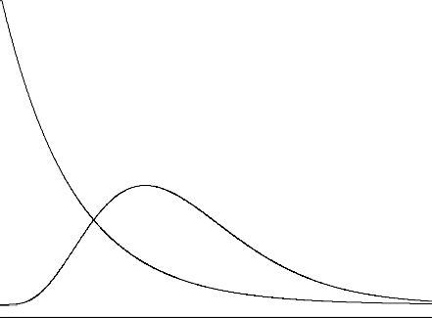

 = 2,  = 1

 = 1,  = 2

 = 1,  = 5

Sources Cited:

* Aerin Kim [Internet] (2020) Beta Distribution – Intuition, Examples, and Derivation
* Somak Sengupta, Great Learning Team [Internet] (2022) Gamma Distribution Explained | What is Gamma Distribution?
* James Chen, Investopedia [Internet] (2022) Normal Distribution: What It is, Properties, Uses, and Formula